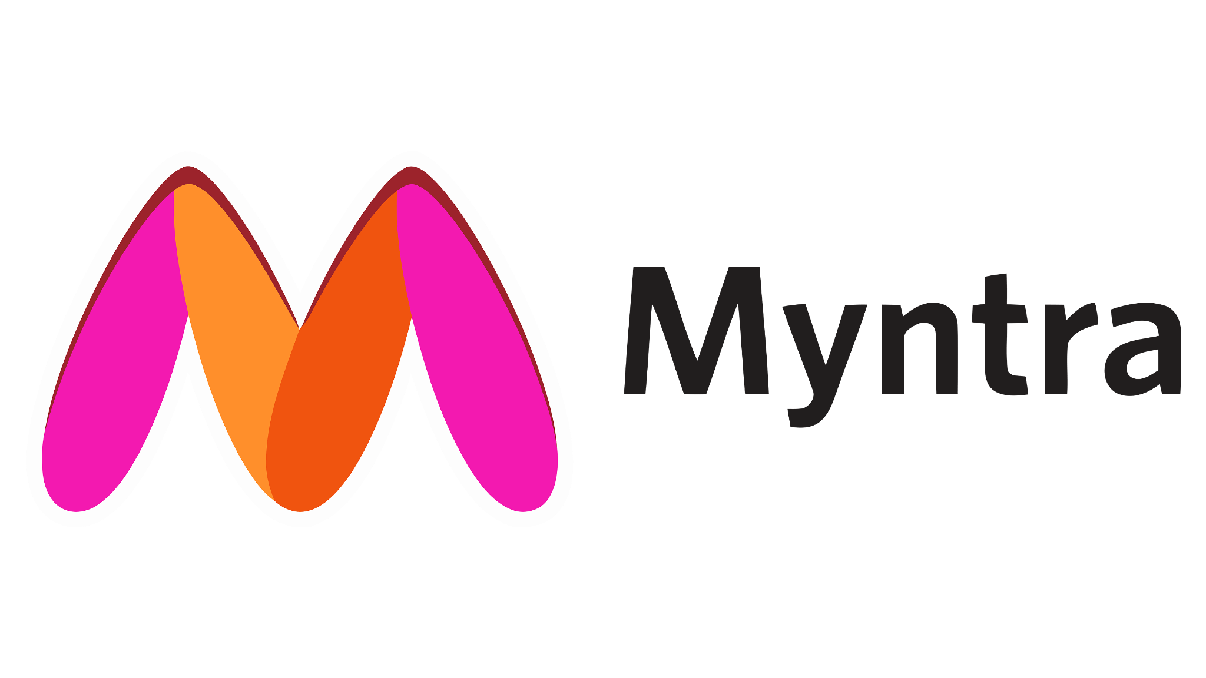

**Product Dissection for Myntra**

### **Company Overview:**

Myntra is considered to be a leading e-commerce platform for fashion and lifestyle-related products in India. It was founded in 2007 but shifted to online retailing of brand apparel in 2010 and was acquired by of Flipkart in 2014. It caters to millions with an extensive portfolio of top international and domestic brands. Pushing the boundaries of traditional e-commerce, Myntra has ventured into 'phygital' commerce (physical+digital), making an offline presence with their 'Myntra Studio'. They are also pioneering the use of AI and ML in fashion, benefitting both consumers with personalized styles and suppliers with demand prediction.

### **Product Dissection and Real-World Problems Solved by Myntra:**

Myntra, a leader in India's online fashion retail, effectively addresses real-world challenges through its innovative product and service offerings. Focusing on promoting a unique and personable shopping experience, Myntra empowers customers to access a wide variety of fashion products tailored to their individual preferences, thus bridging the gap between standardized retail and personalized shopping.

Through an easy-to-use platform, Myntra offers a solution to the need for convenience and variety in shopping. This fundamental attribute resolves the issue of accessibility to an extensive range of fashion brands and products, even in the most remote parts of the country, thereby enabling customers to make purchases that align with their fashion aspirations.

Myntra's AI-powered recommendation engine and unique features, like 'Try and Buy,' further revolutionize the online shopping experience. By addressing the challenge of uncertain fit and style in online shopping, 'Try and Buy' lets customers try out products at home before finalizing the purchase. Moreover, their AI system curates personalized product recommendations, helping customers navigate through an array of items tailored to their fashion preferences.

Additionally, Myntra's user-friendly platform is complemented by initiatives such as Myntra Studio, which provides fashion advice, latest trends, and celebrity styles. This innovative feature aids customers in making informed fashion choices, successfully addressing the challenge of staying current with ever-evolving fashion trends.

In conclusion, Myntra, with its strategic offerings, has tackled real-world problems by creating a platform that prioritizes personalization, convenience, and inclusivity. Providing solutions like 'Try and Buy', AI-based recommendations, and Myntra Studio, the company caters to the contemporary consumer's need for an engaging, streamlined, and personalized online shopping experience.

### **Case Study: Real-World Problems and Myntra's Innovative Solutions**

Myntra, a leader in India's online fashion retail, effectively addresses real-world challenges through its innovative product and service offerings. Focusing on promoting a unique and personable shopping experience, Myntra empowers customers to access a wide variety of fashion products tailored to their individual preferences, thus bridging the gap between standardized retail and personalized shopping.

#### **Problem 1: Inconvenient Shopping**

**Real-World Challenge:** Offline shopping presents significant challenges such as geographical limitations, restricted operating hours, travel and wait times, limited stock availability, and difficulties in product comparison. These barriers impact customer convenience and restrict access to products, especially for people in remote areas or with busy schedules.

**Myntra's Solution:**

The solution to the constraints of offline shopping lies in Myntra's online shopping platform. By eliminating geographical barriers and offering 24/7 availability, it allows customers to shop at any time from anywhere. The platform removes the need for travel and wait times, bringing the entire shopping experience to the customer's fingertips. With a vast array of stock to choose from and easy comparison tools, Myntra empowers consumers with an extensive and flexible shopping experience. This approach efficiently addresses the challenges posed by traditional retail, paving the way for a new era in fashion shopping.

#### **Problem 2: Inaccessibility to brands**

**Real-World Challenge:** The challenges of limited local brand availability, the concentration of international brands in metropolitan areas, and the time and cost associated with travel to physical stores are significant for consumers in remote or underserved areas. Addressing these requires an innovative, accessible solution that can bring a variety of fashion offerings from across the globe directly to these consumers, irrespective of their location.

**Myntra's Solution:**

Myntra offers an innovative solution to these challenges through its online shopping platform. By delivering diverse local and international fashion labels to the doorstep, breaks geographical boundaries and accessibility concerns. The need for time-consuming and costly travels to physical stores is eliminated, providing all customers, irrespective of their location, an opportunity to access and purchase a wide range of fashion offerings with just a click. Hence, Myntra democratizes fashion retail, making it universally accessible and convenient.

#### **Problem 3: Product Overload**

**Real-World Challenge:** What solutions can be provided for the overwhelming product choices available online, the time-consuming process of browsing through numerous items, and the need for personalized marketing campaigns in the face of generic, less effective ones?

**Myntra's Solution:**

Myntra, through its use of AI and machine learning, provides an innovative solution to these challenges. By curating personalized recommendations based on customer preferences and behaviours, Myntra significantly reduces the overwhelming choices and the time spent browsing through numerous items. The technology also enables the creation of customized marketing campaigns, enhancing their effectiveness by tailoring them to individual users. Consequently, Myntra not only streamlines the shopping experience but also makes its marketing strategies more impactful and customer-centric.

#### **Problem 4: Limited reach for Sellers**

**Real-World Challenge:** What are the solutions to the challenges faced by traditional brick-and-mortar retailers such as geographical restrictions, limited customer reach, high initial setup costs, and operational difficulties including inventory, rent, utilities, and maintaining store hours?

**Myntra's Solution:**

Myntra's online marketplace provides an effective solution to these challenges faced by traditional retailers. By eliminating geographical boundaries, it enables brands, especially smaller or emerging ones, to reach a nationwide customer base. The platform significantly reduces the initial setup costs and operational difficulties associated with a physical store, such as inventory, rent, utilities, and maintenance of store hours. Thus, Myntra democratises retail, facilitating easy entry and business growth for sellers irrespective of their size or geographical location.

#### **Problem 5: Unsustainable Fashion**

**Real-World Challenge:** What solutions can be provided to tackle the major environmental issues caused by the fashion industry, lack of consumer awareness about the environmental implications of their purchases, limited options for sustainable products in the mainstream marketplace, and concerns about ethical sourcing in fashion production?

**Myntra's Solution:**

Myntra is addressing these significant concerns by championing sustainable fashion. The platform supports eco-conscious brands and promotes their visibility, providing consumers with mindful choices that challenge industry norms. Through collaborations and awareness campaigns, Myntra educates its customer base about the environmental impacts of their fashion choices, promoting informed purchasing. Further, by fostering ethical sourcing, Myntra is leading the way towards a more responsible and sustainable fashion industry, effectively delivering solutions to these environmental and ethical concerns.

#### **Problem 6: Lack of fashion Advice**

**Real-World Challenge:** How can we effectively address the main challenges in providing fashion advice, rapidly changing trends, the lack of personalized advice, accessibility and affordability of trending styles, the overwhelming nature of vast choices, and the mismatch between offline and online shopping experiences?

**Myntra's Solution:**

Myntra addresses fashion challenges through its user-friendly platform, personalised styling advice, direct access to celebrity-inspired fashion, and AI-powered trend forecasting. A key feature is Myntra Studio, a content hub where customers can get fashion inspiration from favourite influencers, celebrities or Myntra's curated content. It bridges the gap between users and the latest trends, providing styling tips, lookbooks, and easy access to desired products. By fostering a community around fashion, Myntra Studio makes it easy for customers to stay on top of trends, share their styles, and shop with confidence. Hence, Myntra is transforming the shopping experience, making it more interactive, inspiring, and personal.

#### **Problem 7: Uncertainty about Fit**

**Real-World Challenge:** The challenges of online shopping primarily revolve around uncertainties of fit and aesthetic appeal. The lack of standardization in clothing sizes across brands raises questions about fit when shopping online. Moreover, potential discrepancies between digital product representations and their actual look heighten concerns about aesthetic appeal. These uncertainties can lead to increased product return rates and customer hesitancy in making purchases.

**Myntra's Solution:**

Myntra's "Try and Buy" service addresses this fundamental question by allowing customers to try items at home before finalizing their purchase. This service emulates the in-store fitting room experience, effectively eliminating the barriers of fit and look, which are inherent to online shopping. As a result, it significantly amplifies consumer confidence in online purchases, ensuring a more gratifying shopping experience.

#### **Conclusion:**

Myntra's transformation from an online fashion retailer to a prominent e-commerce platform reflects its capacity to identify real-world problems and offer innovative solutions. Myntra's evolution has centred around addressing user challenges within the fashion and lifestyle e-commerce landscape. By fostering user engagement, delivering a diverse product catalogue, and harnessing technology, Myntra has positioned itself as a leader in the Indian online shopping sector. This case study highlights Myntra's user-centric strategy and continuous innovation, showcasing its pivotal role in shaping the way people shop for fashion, accessories, and lifestyle products in the digital age.

### **Top Features of Myntra:**

1. **Wide Product Selection:** Myntra offers an extensive collection of clothing, footwear, accessories, beauty products, and home decor items, catering to diverse fashion preferences.
2. **Personalized Recommendations:** Myntra uses algorithms to suggest products based on a user's browsing and purchase history, enhancing the shopping experience.
3. **Filters and Search:** Users can easily refine their product searches by applying filters such as brand, price range, size, colour, and more. The search functionality helps customers find specific items quickly.
4. **Wish Lists:** Customers can create wishlists to save and track items they're interested in, making it convenient to revisit and purchase them later.
5. **Virtual Try-On:** Myntra employs augmented reality (AR) technology for virtual try-ons, allowing users to visualise how products might look on them, especially for items like eyewear and makeup.
6. **Reviews and Ratings:** Users can read product reviews and check ratings to gain insights from other customers' experiences, aiding in making informed purchase decisions.
7. **Easy Returns and Exchanges:** Myntra offers a user-friendly return and exchange policy, ensuring a hassle-free experience if a product doesn't meet expectations.
8. **Myntra Insider:** A loyalty program that rewards users for their purchases and interaction with the platform, offering points and exclusive benefits.
9. **Myntra Studio:** A section featuring fashion content, including styling tips, trend updates, and articles, inspiring shoppers.
10. **Myntra Fashion Superstar:** A platform for aspiring fashion influencers to showcase their talent and potentially collaborate with Myntra.

### **Schema Description:**

The schema for Myntra involves multiple entities that represent different aspects of the platform. These entities include Users, Orders, Myntra_Insider, Product, Price, Payment, and more. Each entity has specific attributes that describe its properties and relationships with other entities.

**User Entity:**

The user entity contains information about each user:

* **user_id (Primary Key)**: A unique identifier for each user.
* **user_name**: The chosen username for the user's account.
* **email**: The user's email address for account-related communication.
* **phone_num**: The user's mobile number for needed communication.
* **gender**: It specifies the user’s gender for recommendations of the product.
* **enrolled_date**: The date when the user joined Myntra.
* **age:** It defines the user’s age for recommendations of the product.

**Orders Entity:**

Order details for all the orders placed on all the platforms:

* **ord_id (Primary Key):** A unique identifier for each order.
* **user_id (Foreign Key referencing User Entity**): The user who ordered the product.
* **ord_date**: The date when the order was placed.
* **amount**: The amount for that particular order.
* **category**: Specifies the categories to which the order belongs.
* **quantity**: Specifies the number of products for that particular order.
* **ord_from:** Specifies from where the order was placed (App/Website).
* **alter_name:** Indicates the alternative name for that user.
* **alter_num:** Indicates the alternative mobile number for that user.
* **return/replace:** Indicates if the order has to be returned/replaced or not.

**Myntra_insider Entity:**

It specifies the premium users on the Myntra:

* **user_id (Primary Key & Foreign Key referencing user entity)**: A unique identifier for each comment.
* **insider_date:** The date when the user became an insider member.
* **insider_level:** It indicates the level on which the user is (Select/Elite/Icon).
* **reward**: Special gift offered for the user (vouchers/discounts).

**Product Entity:**

It represents information regarding the products:

* **product_id (Primary Key):** A unique identifier for each product.
* **category (Foreign Key referencing orders Entity):** Specifies the categories to which the order belongs.
* **sub_category:** it indicates an additional filter on the category.
* **brand:** Specifies the brand name of the product.
* **size:** It indicates the size of the product.

**Price Entity:**

It indicates the total amount to be paid for a particular order:

* **ord_id (Primary Key & Foreign Key referencing orders Entity)**: A unique identifier for each order.
* **coupon_applied:** It indicates if the user has applied the coupon or not.
* **mrp:** The maximum amount of the product.
* **discount:** Percentage of reduction offered on MRP.

**Payment Entity:**

It indicates the information about the payment gateway:

* **transaction_id (Primary Key)**: A unique identifier for each transaction.
* **ord_id (Foreign Key referencing orders Entity)**: A unique identifier for each order.
* **mode_of_payment:** Specifies the payment option chosen by the user.

**Delivery Entity:**

Information about the delivery of the product:

* **ord_id (Primary Key & Foreign Key referencing orders Entity)**: A unique identifier for each order.
* **ord_date**: The date when the order was placed.
* **deli_expected_date**: The date on which the order is expected to be delivered.
* **deli_actual_date**: The date on which the order is delivered.

**Relationships are:**

* **Users order Orders –** Each user can order multiple orders, but each order will have only one user.
* **Users as Myntra Insider –** EachMyntra Insider will be a user, but each user may or may not be a Myntra insider.
* **Order as product -** One order can have one or more than one product but a product can be ordered multiple times or not ordered.
* **Order price -** An order will have one price to be paid and the price is the amount which will be linked to only one product
* **User order delivered** - A user can order multiple times with its price and payment has to be made accordingly, if the payment is done the order will be delivered.

**ER Diagram:**

Let's construct an ER diagram that vividly portrays the relationships and attributes of the entities within the Myntra schema. This ER diagram will serve as a visual representation, shedding light on the pivotal components of Myntra's data model. By employing this diagram, you'll gain a clearer grasp of the intricate interactions and connections that define the platform's dynamics.

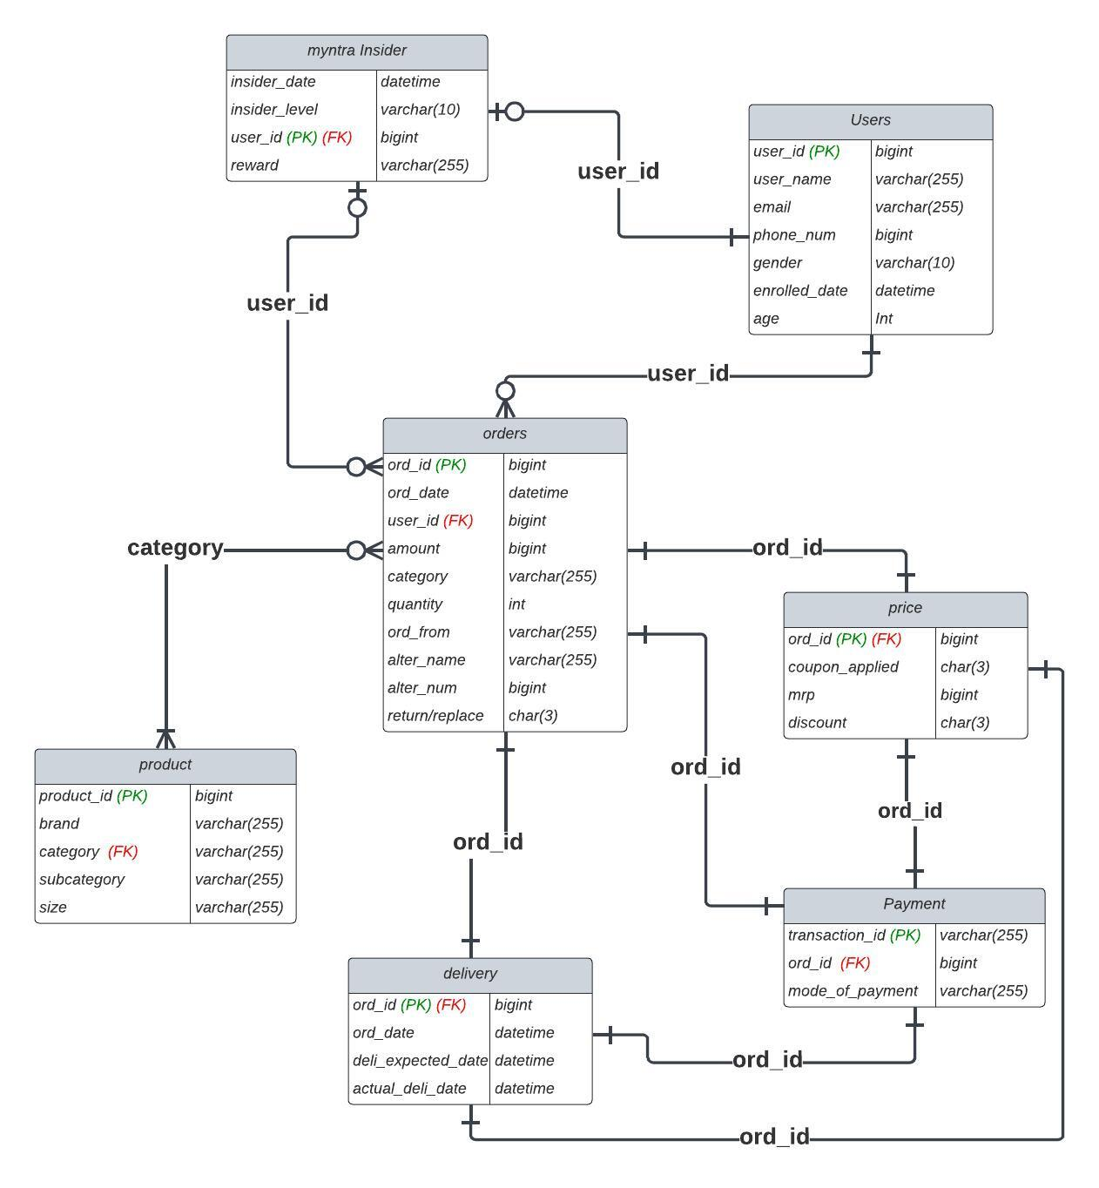

### **Conclusion**

This case study elucidates Myntra's intricate data schema and Entity-Relationship diagram that underpins its robust fashion e-commerce platform. Myntra's fruitful transformation of online fashion shopping results from its comprehensive data model, which includes entities like users, products, orders, and Myntra insiders. This organised structure manages complexity by interconnecting various facets of e-commerce, from browsing to purchasing. Understanding Myntra's data schema offers valuable insights into its effective orchestration of user interactions, inventory management, sales strategy, and enhanced customer experiences, thereby contributing to its sustained growth in the digital fashion marketplace.

### **Submitted By:-**

1. **Mohit**